**Background Information**

In a Stroop task, participants are presented with a list of words, with each word displayed in a color of ink. The participant’s task is to say out loud the *color of the ink* in which the word is printed. The task has two conditions: a congruent words condition, and an incongruent words condition. In the *congruent words* condition, the words being displayed are color words whose names match the colors in which they are printed: for example RED, BLUE. In the *incongruent words* condition, the words displayed are color words whose names do not match the colors in which they are printed: for example PURPLE, ORANGE. In each case, we measure the time it takes to name the ink colors in equally-sized lists. Each participant will go through and record a time from each condition.

# Questions For Investigation

1. What is our independent variable? What is our dependent variable?

The independent variable is the type of condition, either congruent or incongruent.

The dependent variable is the time it takes to name the ink colors in an equally-sized list.

1. What is an appropriate set of hypotheses for this task? What kind of statistical test do you expect to perform? Justify your choices.

In 1886, Cattell showed that it takes considerably less time to read an object’s name than to see an object and name it. In 1935, Stroop combined these two dimensions into a single task described in the Background Information section above. Stroop showed that individuals normally have little difficulty under congruent conditions; however, they tend to struggle and are error prone under incongruent conditions. Thus, tests under incongruent conditions will take longer than those under congruent conditions. [1] So in order to confirm what has become known as the Stroop effect, the null hypothesis must be that the time it takes to finish a test is constant regardless of condition or that a test under congruent conditions will take longer to finish than one under incongruent conditions. The alternative hypothesis is that tests under congruent conditions take less time to complete than those under incongruent conditions. Both the null and alternative hypotheses are described mathematically below.

$$H_{0}:μ_{c}- μ_{i} ≥0$$

$$H_{A}:μ_{c}- μ_{i} <0$$

Where $μ_{c}$ and $μ_{i}$ are the population means, time it takes to complete tests under congruent and incongruent conditions respectively. A within-subject design one-tailed t-test with an $α$ level of 0.05 or lower should be conducted in order to confirm the Stroop effect. Due to the population parameters being unknown, the relatively small sample of n equal to 24, and the fact that we assume that the population can be modeled by a normal distribution, a t-test should be used. Due to how the test is constructed, there should be minimal to no carry-over effects between tests. In addition, test order should have minimal to no effect due to the same reason.

1. Report some descriptive statistics regarding this dataset. Include at least one measure of central tendency and at least one measure of variability.

Descriptive statistics for the congruent and incongruent tests, as well as the difference between them are included below.

Congruent: sample mean, 14.05, median, 14.36, sample standard deviation, 3.56, Q1, 11.53, Q3, 16.59, Interquartile Range (IQR), 5.07

Incongruent: sample mean, 22.02, median, 21.02, sample standard deviation, 4.80, Q1, 18.67, Q3, 24.37, Interquartile Range (IQR), 5.70

Difference: sample mean, -7.96, median, -7.67, sample standard deviation, 4.86, Q1, -10.72, Q3, -3.48, Interquartile Range (IQR), 7.24

1. Provide one or two visualizations that show the distribution of the sample data. Write one or two sentences noting what you observe about the plot or plots.

Figure 1 shows a box and whisker plot of the congruent and incongruent test samples. Note that our samples contain no outliers.

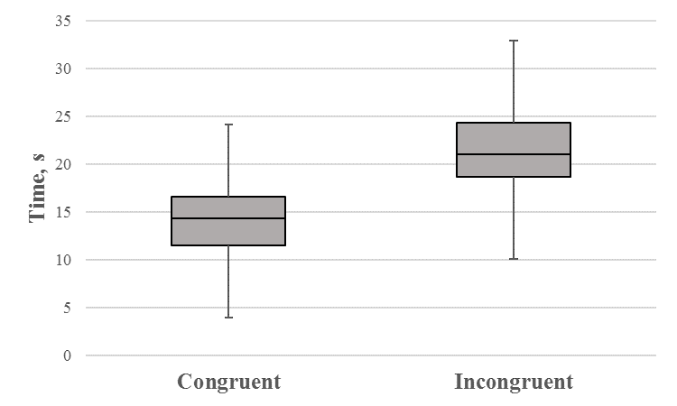

**Figure 1.** Congruent and incongruent Stroop test box and whisker plot.

Figure 2 displays a bar graph of times for congruent (red) and incongruent (blue) tests, as well as an overlay of each perspective tests normal distribution. The figure shows that on average individuals finished tests under congruent conditions faster than incongruent conditions, which appears to confirm the Stroop effect.

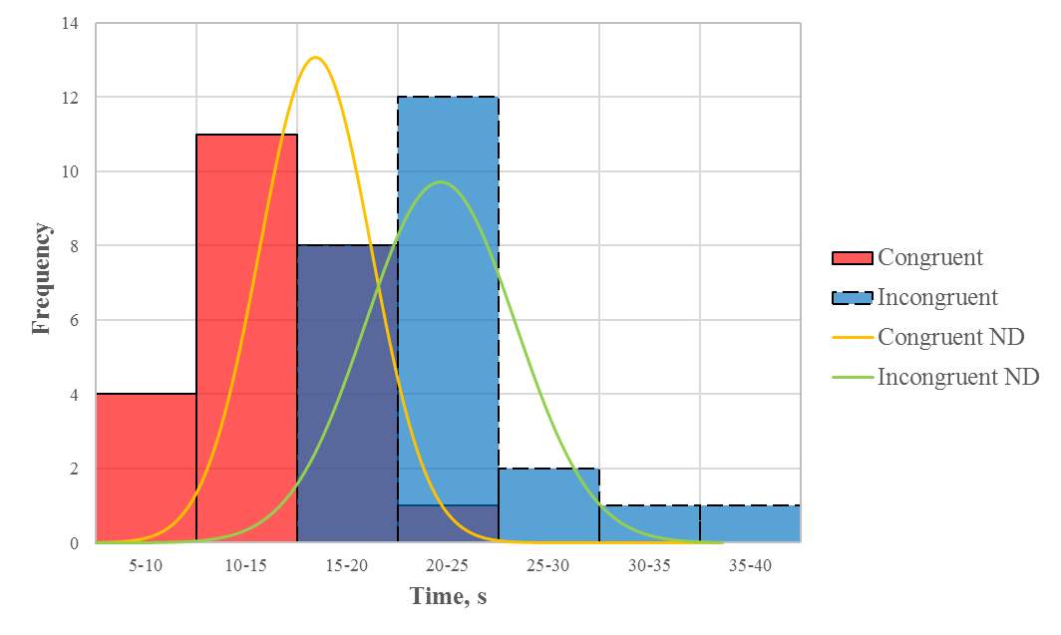

**Figure 2.** Congruent and incongruent Stroop test comparison histogram.

1. Now, perform the statistical test and report your results. What is your confidence level and your critical statistic value? Do you reject the null hypothesis or fail to reject it? Come to a conclusion in terms of the experiment task. Did the results match up with your expectations?

Since I chose a 1 tail t-test with an $α$ level of 0.001, my confidence level and t-critical value are 99.9% and -3.4850 respectively. My t-statistic was -8.02, which results in a p-value of less than 0.0001; so, the null hypothesis is rejected. This confirms the Stroop effect, which predicts that it will take less time on average to name the ink colors in an equally-sized list under congruent conditions than the incongruent conditions.

# References

[1] R. Corsini, W. Craighead and I. Weiner, The Corsini encyclopedia of psychology, 1st ed. Hoboken, NJ: Wiley, 2010.